TACTILE BOOKS BORROWING FORM
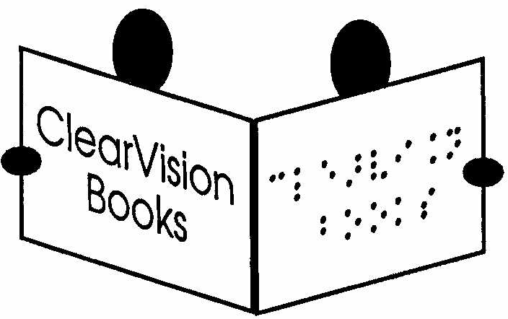

About us
ClearVision’s postal library includes a collection of over 800 handmade tactile books with tactile illustrations for children with sight impairment who are over three years old and developing tactile skills. Some books are also suitable for older children who read braille and enjoy tactile illustrations, and many are suitable for children with sight impairment and additional disabilities or learning difficulties. For health and safety reasons, ClearVision lends tactile books only to schools, nurseries, Sensory Support Services and other educational establishments. Tactile books must be borrowed primarily for the use of children with sight impairment, used one-to-one with an adult, and must not be taken home by children.

About the Books
Most tactile books are robust, handmade fabric books with real objects or pictures made from realistic textures, helping children connect what they feel in the book with objects they have touched in the real world. The collection also includes collage books and a small number of embossed or 3D printed books. Most books have been made by volunteers, while some have been bought from producers abroad, including winners of the Typhlo & Tactus Award for tactile books. The collection includes early learning topics, pre-braille skills, nursery rhymes, poems, counting books, non-fiction and stories for a range of ages. Most books have braille or Moon, although this may sometimes be limited to a key word, and some have large print.
The collection was developed with funding from the Ulverscroft Foundation, the Blatchington Court Trust, the Esmee Fairbairn Foundation and the Henry Smith Charity. ClearVision also thanks the many hundreds of people who have made and donated books to create this collection -– the first of its kind in the UK. We are always looking for volunteers to create new books and we give talks to craft/volunteer groups on book construction. Please see the ‘tactile book’ page of our website and contact us if you can help.

Borrowing Procedure
Please complete this form if you would like tactile books as all or part of your loan. If you only want interleaved print-and-braille books or short chapter books, you do not need to complete this form. Please complete the relevant sections, ticking or circling answers where appropriate, and ensure that the declaration at the end of this form is signed.

APPLICATION TO BORROW TACTILE BOOKS

1. Which of the following applies to your institution?
☐ My institution is already a member of ClearVision and we would like to receive tactile books as part of our existing subscription. Please adjust our next loan according to the details in this form.
☐ My institution is already a member of ClearVision and we would like to take out an additional subscription to borrow tactile books in addition to the books we already receive. Please invoice us for £60 if this has not already been paid.
☐ My institution has not borrowed from ClearVision before. Please send us an invoice if one has not already been issued.

Number of Books
Each £60 subscription entitles the borrowing institution to up to 20 units of loan. Different types of books count for different numbers of units (please see further details below): an interleaved print-and-braille book counts as one unit; a short chapter book counts as two units; and a tactile image book counts as four units. Borrowers may mix and match book types up to a maximum of 20 units. For example, a borrower could borrow two tactile books, counting as eight units, and 12 interleaved print-and-braille books, counting as 12 units. If borrowing tactile books only, a borrower may borrow up to five tactile books at once.
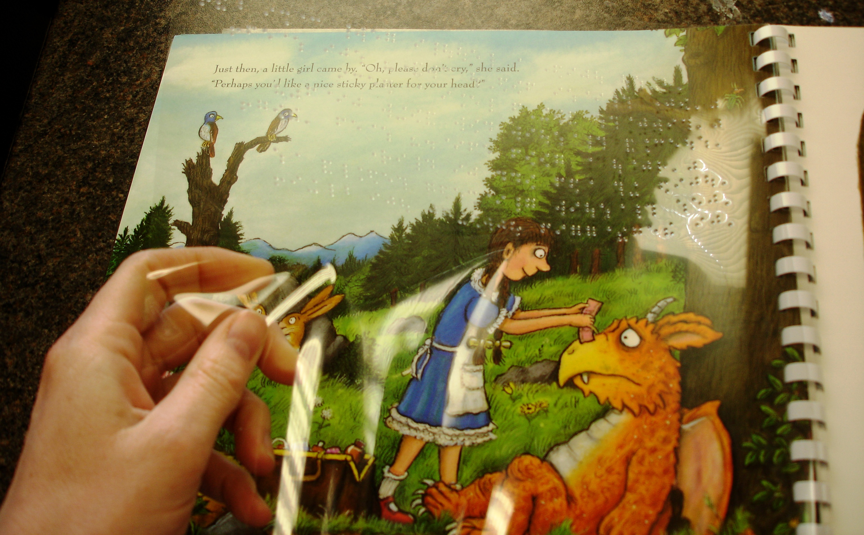
An interleaved print-and-braille book = 1 unit (this includes our story books, non-fiction, baby and toddler board books, and most of our Easy Reading for Teenagers titles).

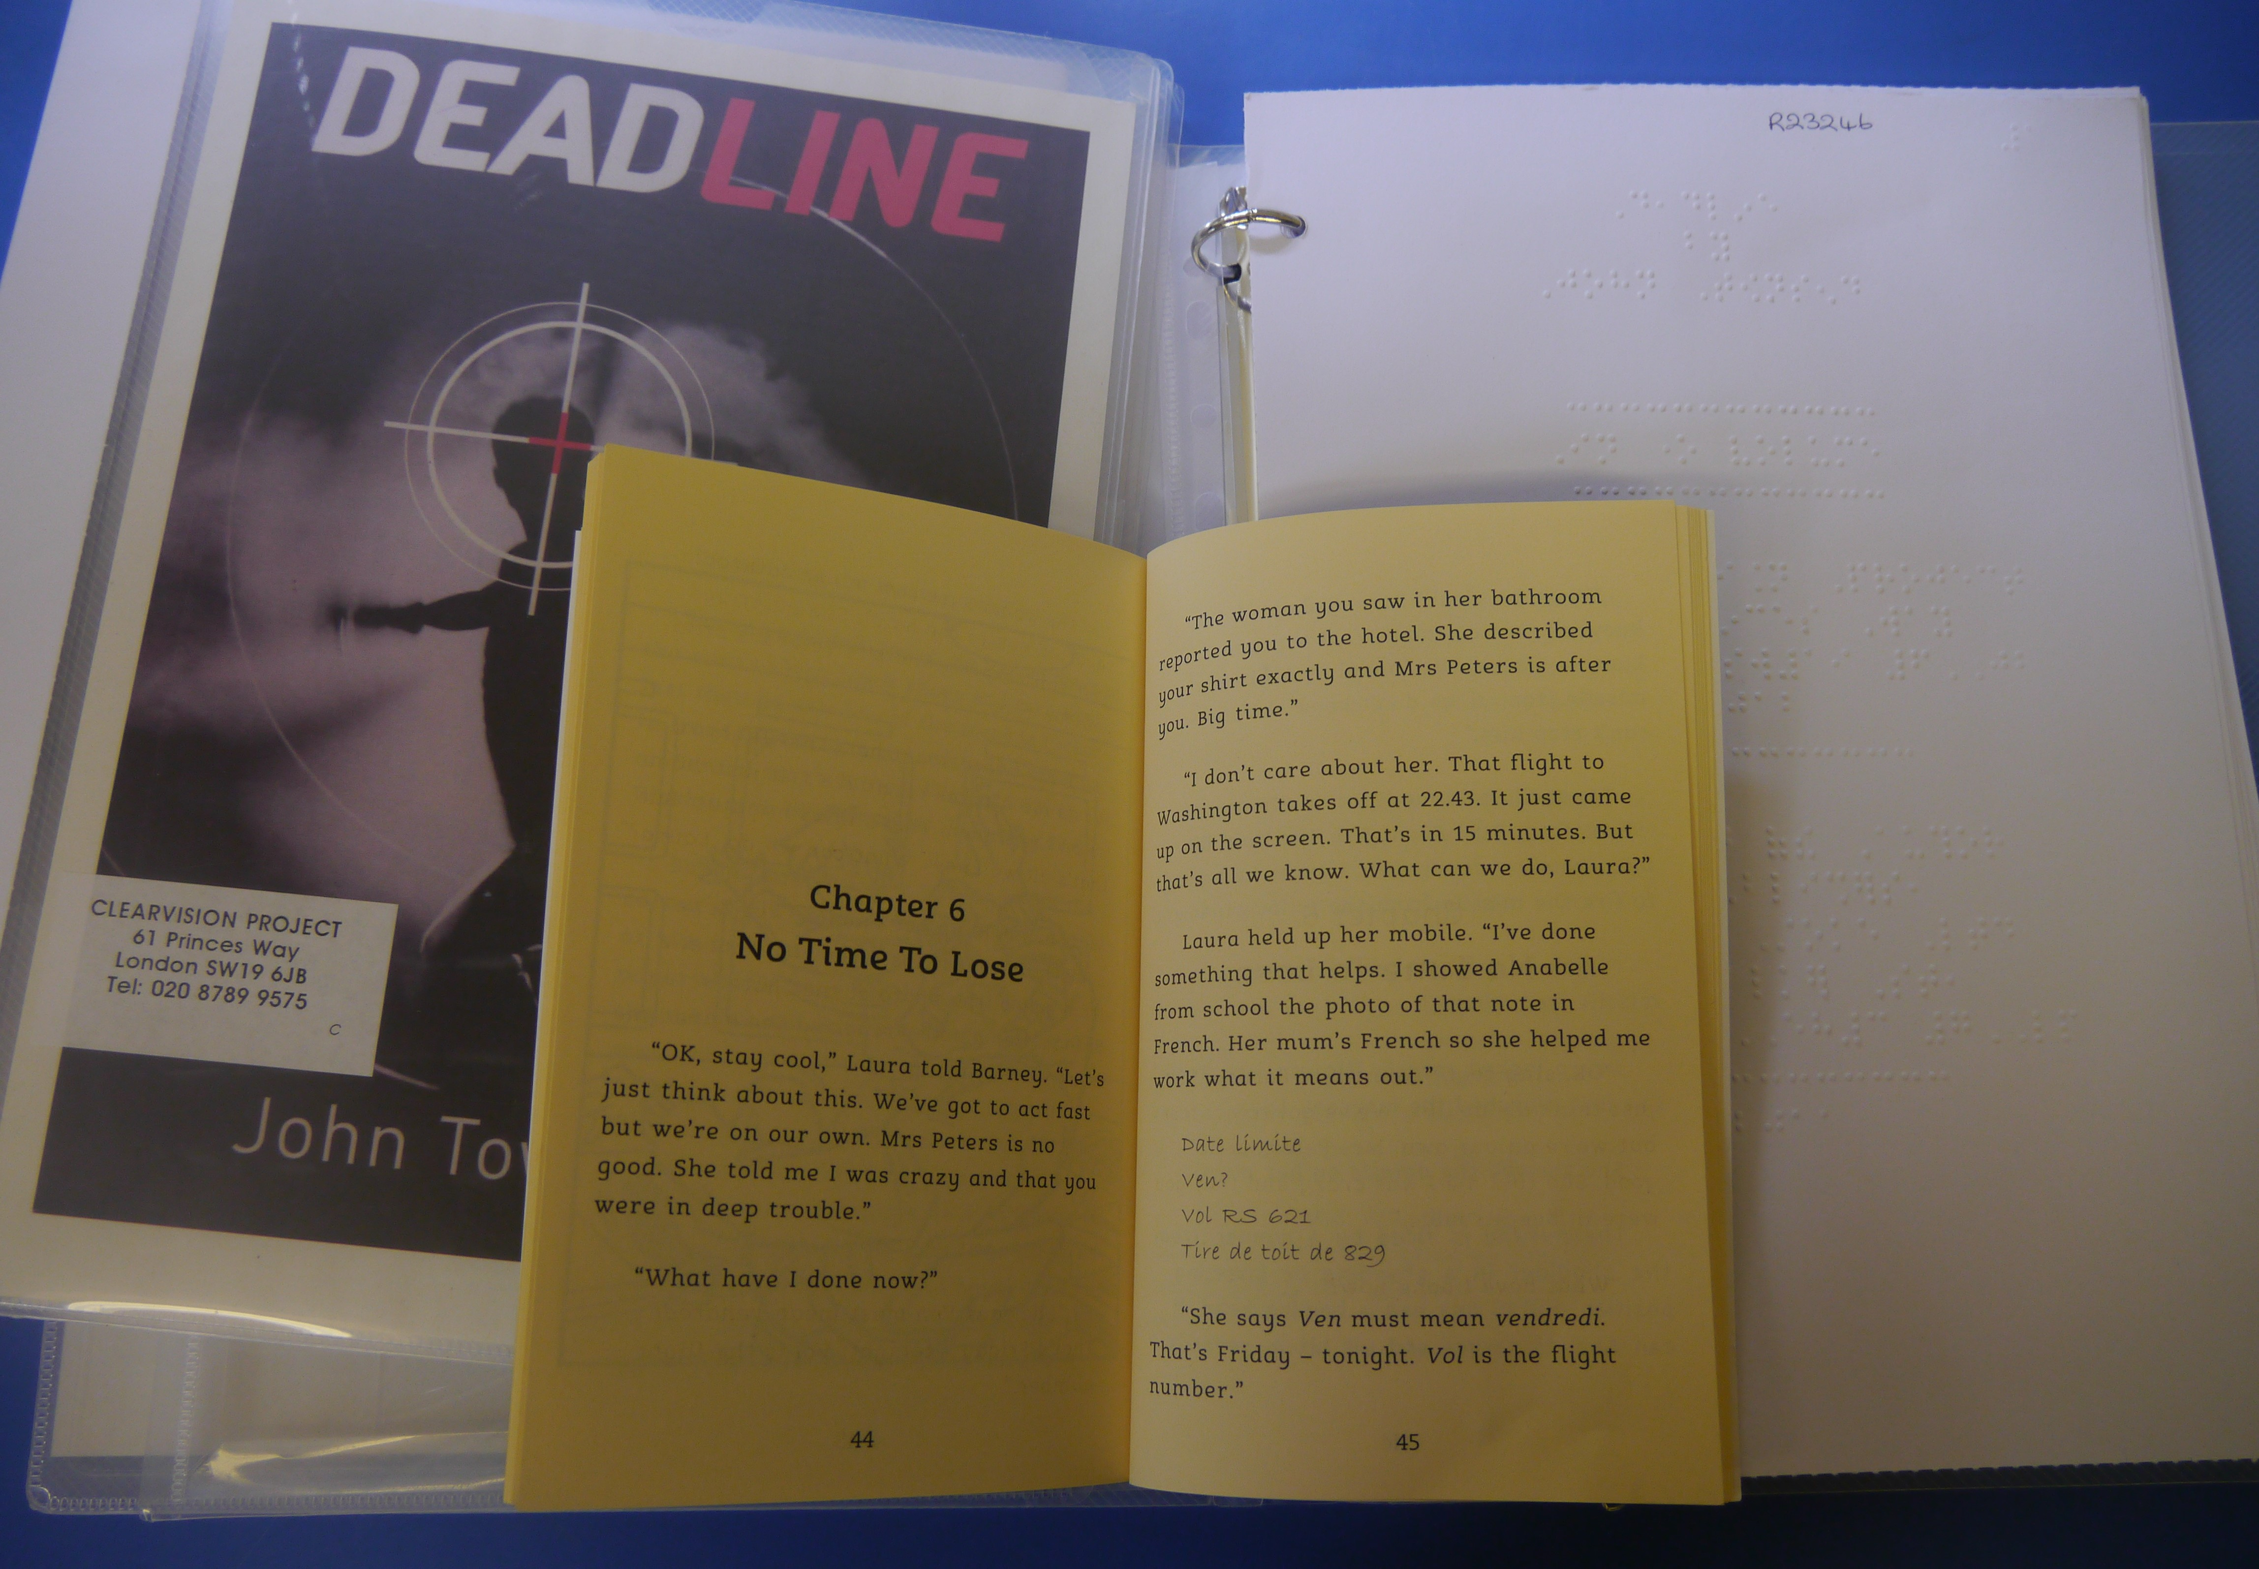
A short chapter book = 2 units (a print book and a braille copy together in a folder, suitable for newly-fluent readers; includes some of our longer Easy Reading for Teenagers titles)

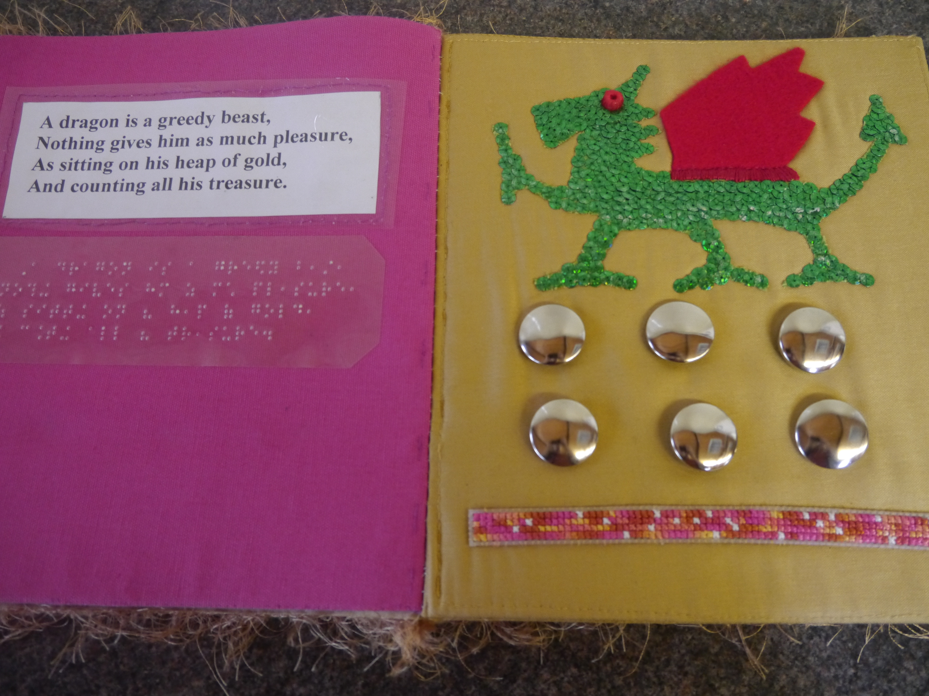
A tactile image book = 4 units.

Loans may be exchanged up to six times a year, and the breakdown of the loan may be changed each time. Please email or call ClearVision when returning books and let us know what you would like next. If ClearVision does not hear from you, it will send similar books in the same proportions as the previous loan.

2. How many of each type of book would you like to receive?
Please make sure that the total does not exceed 20 units.

Type of book | Units per book | Quantity requested | Total units
Interleaved print-and-braille book | 1
Short chapter book | 2
Tactile book | 4
Total (max. 20 units)

Needs of the Child or Children
The following questions ask about the needs of the child or children who will use the tactile books. If the loan will be split between several children with very different needs, please complete a separate copy of this section for each child.

3. Which of the following best describes the child or children?
☐ In the early stages of tactile development and needing stimulation.
☐ Able to distinguish simple shapes and textures and taking an interest in tactile books.
☐ Developing fine motor skills and starting to interpret tactile pictures.

4. When handling books, the child or children are usually:
☐ Boisterous
☐ Over-enthusiastic
☐ Quite careful
☐ Very careful

5. Age of child or children:
☐ 3–4
☐ 5–6
☐ 7–9
☐ 10+

6. Ideally, the books should have:
Please circle your first choice and underline any other acceptable options so that ClearVision can select from the widest suitable range of books.
Grade 1 braille labels / Grade 2 braille labels / Moon labels / Either braille or Moon / Labels not important

7. Does the child or children have any disabilities in addition to sight impairment?
Yes / No
Please include any relevant details, for example hearing impairment, preferences for or against sound elements, sensory preferences, or textures to avoid.
………………………………………………………………………………………………………………………………………………………………………………………………………………………………………………………………

8. What is the child or children’s sight like?
Please underline all that apply and include any relevant details, for example whether it would be appropriate for ClearVision to send books about colour.
Good vision but would benefit from tactile elements / Some vision and can see bold colour contrasts / Very low vision and cannot see colour or bold outlines / Light perception only / No sight / CVI (please detail their preferences):
………………………………………………………………………………………………………………………………………………………………………………………………………………………………………………………………

9. Please provide any other relevant information about the child or children.
Please include interests, reading level if applicable, preferred topics, sensory preferences, or any information that may help ClearVision choose suitable books.
………………………………………………………………………………………………………………………………………………………………………………………………………………………………………………………………

ACCEPTANCE OF LOAN CONDITIONS
These tactile books are very special, and ClearVision requires written acceptance of the following conditions before sending the first loan.
The books are not suitable for children under three years old. All children must be constantly supervised by an adult when using the books. Most books in the collection are handmade and designed to give children plenty to explore by touch. ClearVision does its best to make sure the books are safe, but small items could be pulled off the page and swallowed or could otherwise harm a child.
The books must not be loaned to children or their families for home use. The books remain the responsibility of the borrowing school, service or educational establishment while they are on loan. Great care must be taken to protect the books from loss or damage because they take significant time, effort and skill to produce, and many are unique. ClearVision may invoice the borrowing institution up to £40 if a book is not returned in reasonable condition. Books should be changed at least once a term, or every four months, because they are in high demand and need to remain in circulation.

Liability Disclaimer and No Recourse
The borrowing institution acknowledges that the tactile books are handmade, varied in design and materials, and supplied for supervised educational use only. The borrowing institution accepts responsibility for assessing whether each book is suitable for the child or children using it, taking into account their age, needs, behaviour, sensory preferences, additional disabilities and any other relevant circumstances. The borrowing institution must ensure that the books are used only under constant adult supervision and in accordance with these loan conditions.
To the fullest extent permitted by law, the borrowing institution agrees that it shall have no recourse against ClearVision, its trustees, officers, employees, volunteers, agents, contractors, funders or other relevant persons in respect of any claim, loss, damage, injury, cost or expense arising out of or in connection with the selection, condition, loan, use, supervision, handling, loss of, or damage to, any tactile book or related product. Nothing in this form excludes or limits any liability that cannot lawfully be excluded or limited.

Declaration
We would like to borrow tactile books from ClearVision for a child or children with sight impairment who are over three years old. We understand and accept the loan conditions set out in this form and will make sure that they are understood and followed by everyone using the books while they are on loan to this establishment. We confirm that the books will be used only in accordance with these conditions, including the requirements for one-to-one adult supervision and no home use. We further confirm that the relevant teacher or school room attendant (or other relevant persons) responsible for using the tactile books with the child or children has been made aware of, and agrees to comply with, the loan conditions set out in the Acceptance of Loan Conditions section of this form, including the requirements relating to constant adult supervision, the prohibition on home use and the obligation to protect the books from loss or damage.
This form must be signed by the Principal/Head of the borrowing school. Where the borrowing institution is not a school (for example, a Sensory Support Service) the form must be signed by the equivalent Head of the institution or service. Wet-ink signatures or e-signatures must be used, and typed names alone are not sufficient.

Principal / Head of Institution/ Head of Service:
Name: ………………………………..
Signature: ………………………………..
Date: ………………………………..
Relevant Institution: ………………………………..
Telephone: ………………………………..
Address: ………………………………..………………………………..………………………………..………………………………..………………………………..….……………………………..………………………………..……………………
Email: ………………………………..
Please email this completed form as a pdf, or a scan or photograph of it, to ClearVision at info@clearvisionproject.org, or post it to ClearVision Project, Linden Lodge School, 61 Princes Way, London SW19 6JB

